Technical Design for Component A
Revision History

Issue | Date | Person | Reason
0.1 | month dd, yyyy | <Name> | <Description>
1.0 | month dd, yyyy | <Name> | <Description>

Description
The following sections provide the reader with an overall understanding of the component, the tasks it needs to perform and why it must do them. You don’t actually write anything here. You write in the 1.1 section.

Introduction
This section contains an overview of the component, what it is intended to do, the purposes it will fulfill, and its overall role in the application and any other introductory information you think is useful.

Example:

The navigation hand directs the user towards the next navigation point in the map on the way towards his eventual destination of the drop-off for the current passenger. The hand is only visible when the player has a passenger.

Requirements
This section is a point-form list of all the operations this components must fulfill including the other components that will need to use it. Include a short description (perhaps two lines) for all points you feel need explaining Also be explicit about what the component will NOT do if there is any ambiguity.

Example:

- Point towards the next navigation point - The next navigation point is determined by the Creampuff algorithm and based on information provided by the Cheese Factory
- Look like a cartoon hand

References
This is a point-form list of everyone you talked to do develop the above requirements. This helps us analyze the validity and importance of each requirement. Also, if a requirement needs an explanation we know who to go bug about it.

Example:

- Talked to Joe about the need for the hand
- Talk to Yayoi about the appearance of the hand
- Talked to Darwin about the Creampuff Algorithm

Technical Design
In this section you should choose the sections you find useful to describe the specifics of your component’s operation. You don’t actually write anything here. You write in 2.1.

Relationships
Construct a diagram or write a text description of the relationships your component has with other components in the application.

For instance, list any components from which your component requires information, components that use your component, and components that are dependent upon your component for information.

This section is very important because it is used to tie together the overall tech design and keep it consistent. Poor planning in this section will result in headaches later in the project when we realize component B was never intended to work with Component A, but suddenly it has to.

Interface
Write and explain an interface for your component. If you want to write a prototype for your component first, or try it in code before hand, simply explain the requirements of your interface based on the information in the Relationships section.

Example:

class CNavArrow : public Whatever
{
public:

CNavArrow( Player* pPlayer );
~CNavArrow();

virtual void Render();

void Update();

void SetTarget( rmt::Vector target );
void ForceNextTarget() { m_forceNextTarget = true; }
void GetHeading( rmt::Vector &heading ) const;
rmt::Vector GetTarget() { return( m_target ); }
float GetTargetDistance() const;

void EnableDisplay() { m_displayEnabled = true; }
void DisableDisplay() { m_displayEnabled = false; }
}

Component Class Diagrams
Make a diagram or write a text description of the classes in your component and how they relate to each other and communicate internally (i.e. within the component) to operate.

Example:
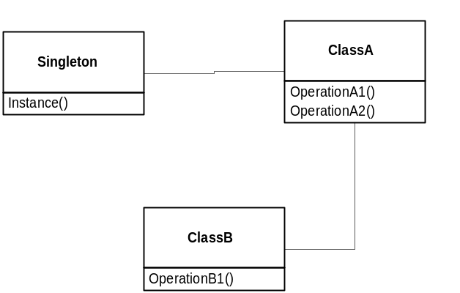

Also include a diagram or description of the hierarchy to which these classes belong.

Example:

BaseClassA
|
ClassA
|
ClassB

Use Cases
Describe one or more examples of your component in action. This section should describe the inputs, the internal operation, and the outputs of your component in the context of this use case.

With a diagram or text description list the function calls made into and by your component and the classes within your component. This is analogous to the Sequence Diagram in UML, which shows function calls connected with arrows and little numbered instructions to show the order of execution.

Example:

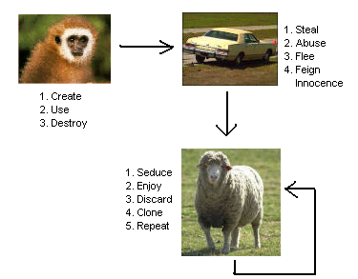

Choose use cases that give the widest possible coverage of operation for your component. Also describe how the classes within the component play a part in the overall operation in this use case.

Accompany this description with state diagrams if you think they would be helpful to understand the use case. Pay particular attention to how the use cases relate to the Relationships section.

Darwin says that if you work hard and get this section right, chances are your design will be successful later in the project.

